WALK AND TALK 2024

Quadrangle Introductions - George Robson and Chris Robson.

Pass through the lych gate and view the graves/memorials of the following before reaching the priory entrance:
Each location is highlighted by a RED ROSE and a PHOTOGRAPH.

Sharm Oates - Student at the Theological College (d. 1865).

Emil Züllig – Master (d. 1914).

World War One and World War Two Village Memorials.

Rev. Geoffrey Moule - School Chaplain (1950s-60s).

Dinah Haile - Ran a tuck shop next to Grindal.

Tony Cotes – Master (1959-90).

Bill Fox – Bursar (FN 35-40/Bursar 60-80).

IN THE PRIORY THERE WILL BE PRESENTATIONS BY CHRIS ROBSON, GEORGE ROBSON AND PRIORY ORGANIST FRANK BOWLER, followed by some time to look around the Priory and Old College Hall.

Move on to the next section of the churchyard to view the
graves of:

Thomas Brown – Master (1941-70) and Housemaster, and his wife Mary who also taught at the school.

Sam Parkinson – Schoolmaster (1948-75), and his wife Margaret.

May Dodds - Foundation Matron for 47 years.

David Lyall - Schoolmaster (1952-91) and Housemaster, and his wife Jean.

PASS ON INTO THE COMMUNITY GARDEN AND RETURN TO SCHOOL VIA THE DANDY WALK.
A FEW OF OVER 300 HYMN TUNES COMPOSED BY JOHN DYKES (1823 – 1876)

MELITA -  Eternal Father strong to save  GERONTIUS -  Praise to the holiest in the height  NICAEA -  Holy, holy, holy, Lord God Almighty  DOMINUS REGIT ME -  The King of Love my Shepherd is  VOX DILECTI -  I heard the voice of Jesus say  HORBURY -  Nearer my God to thee | 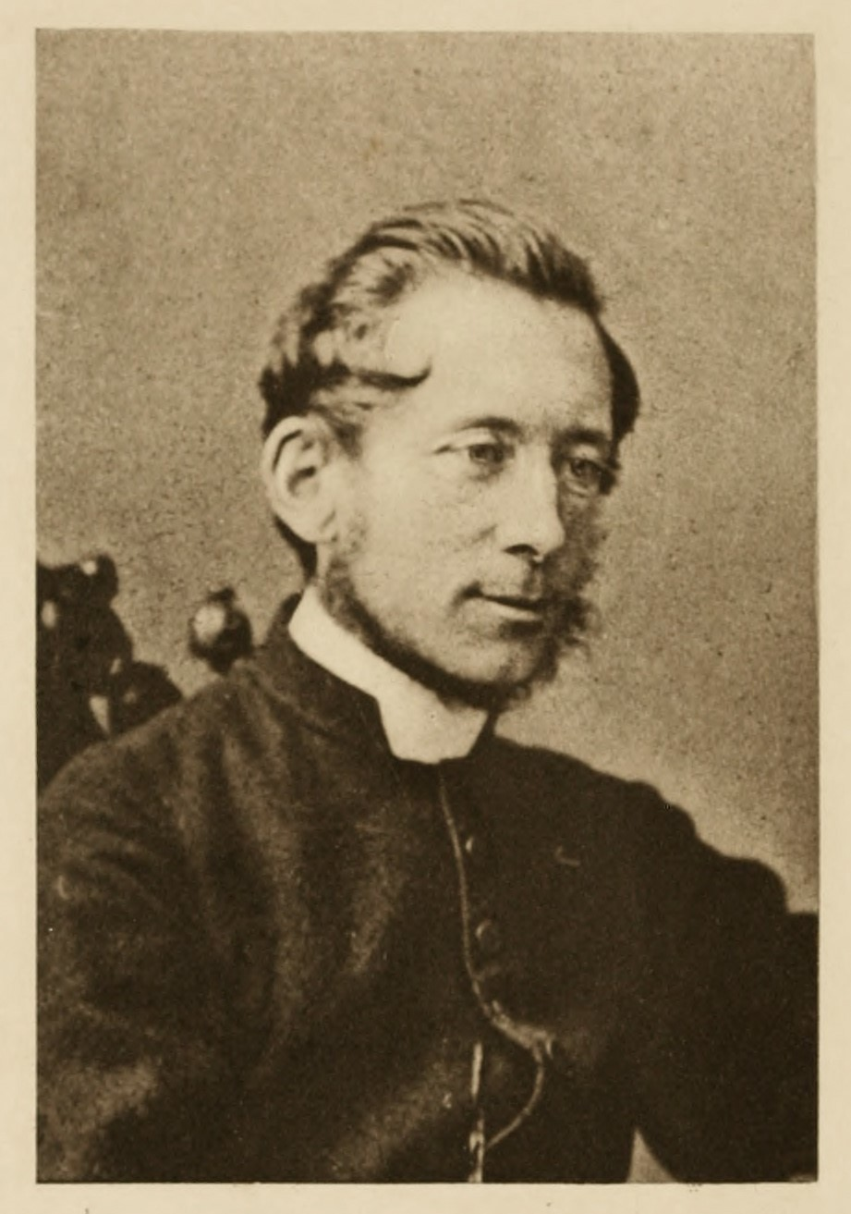
ST BEES - HARK MY SOUL IT IS THE LORD

1. Hark my soul it is the Lord 3.Mine is an unchanging love

‘Tis thy Saviour, hear his word. Higher than the heights above.

Jesus speaks, and speaks to thee, Deeper than the depths beneath,

‘Say, poor sinners, lov’st thou me? Free and faithful, strong as death

2.I delivered thee when bound, 4.Lord it is my chief complaint

And when bleeding healed they wound; That my love is weak and faint

Sought thee wandering, set thee right. Yet I love thee, and adore

Turned thy darkness into light. O for grace to love thee more!

